H.T No
Regulations:
A14

Sreenidhi Institute of Science and Technology
(An Autonomous Institution)
Code No: 4AC07 Date: 06-Oct-2020 (AN)

B.Tech IV-Year I-Semester External Examination, October - 2020 (Supplementary)
CONTROL SYSTEMS (ECE)

Time: 2 Hours Max.Marks:70

Note: a) No additional answer sheets will be provided.
b) All sub-parts of a question must be answered at one place only, otherwise it will not be valued.
c) Missing data can be assumed suitably.

ANSWER ANY FIVE QUESTIONS. EACH QUESTION CARRIES 14 MARKS.

1. | a) | Explain the effects of feedback. | [7M]
 | b) | Find the transfer function X₁(S)/F(S) for the mechanical system shown below. | [7M]
2. | a) | Derive the expression for Peak time of a standard second order system. | [7M]
 | b) | Find the rise time t_{r} and settling time t_{s} when the system is subject to a unit step input for the 2nd order control system, where ξ = 0.6 & Wn = 5 rad / sec. | [7M]
3. | a) | Define root locus. | [7M]
 | b) | Sketch the root locus for the given unity feedback system shown in below figure. 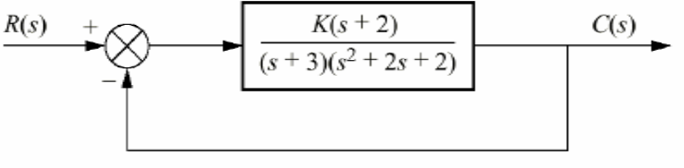 | [7M]
4. | a) | Explain the frequency response specifications. | [7M]
 | b) | Draw the Bode Plot for the system having  G(s) H(s) =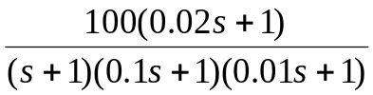.  Find gain and phase cross over frequency. | [7M]
5. | a) | Construct the complete Nyquist plot for a unity feedback control system whose open loop transfer function is  G(s)H(s) = 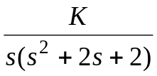.  Find maximum value of K for which the system is stable. | [7M]
 | b) | What is a lag compensator, obtain the transfer function of lag compensator and draw pole-zero plot? | [7M]
6. |  | Find the state transition matrix for the system given by  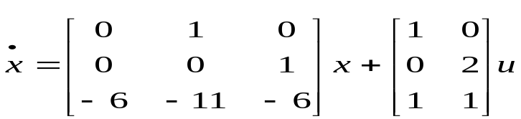 | [14M]
7. | a) | Give different classifications of control systems. | [6M]
 | b) | What are different static error constants? | [4M]
 | c) | Explain qualitative and conditional stability from R-H criterion. | [4M]
8. | a) | Explain the procedure for finding transfer function from the Bode plots. | [6M]
 | b) | Differentiate Lead-Lag compensation techniques. | [4M]
 | c) | Explain the diagonalization with suitable matrix. | [4M]

-- 00 -- 00 –

